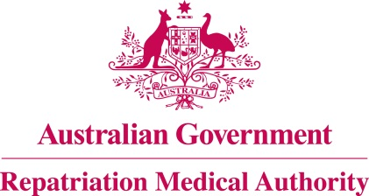

Amendment Statement of Principles

concerning

TOOTH WEAR
(Balance of Probabilities)

(No. 86 of 2018)
The Repatriation Medical Authority determines the following Amendment Statement of Principles under subsections 196B(3) and (8) of the Veterans' Entitlements Act 1986.

Dated 24 August 2018

The Common Seal of the
Repatriation Medical Authority
was affixed to this instrument
at the direction of:

Professor Nicholas Saunders AO
Chairperson

Contents
1 Name 3
2 Commencement 3
3 Authority 3
4 Amendment 3

- Name
This is the Amendment Statement of Principles concerning tooth wear (Balance of Probabilities) (No. 86 of 2018).
- Commencement
This instrument commences on 24 September 2018.
- Authority
This instrument is made under subsections 196B(3) and (8) of the Veterans' Entitlements Act 1986.
- Amendment
The Statement of Principles concerning tooth wear (Balance of Probabilities) (No. 53 of 2017) (Federal Register of Legislation No. F2017L01062) is amended in the following manner:

Section | Amendment
8(2)(j) | Insert the following factor in subsection 8(2)(j):  vomiting or regurgitating gastric contents on at least 100 occasions within the one year before the clinical onset of tooth wear;
8(4)(j) | Insert the following factor in subsection 8(4)(j):  vomiting or regurgitating gastric contents on at least 100 occasions within the one year before the clinical worsening of tooth wear;

