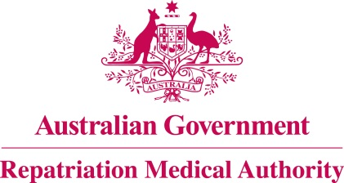

Amendment Statement of Principles

concerning

MALIGNANT NEOPLASM OF THE OESOPHAGUS
(Reasonable Hypothesis)

(No. 21 of 2017)
The Repatriation Medical Authority determines the following Amendment Statement of Principles under subsections 196B(2) and (8) of the Veterans' Entitlements Act 1986.

Dated 20 December 2016

The Common Seal of the
Repatriation Medical Authority
was affixed to this instrument
at the direction of:

Professor Nicholas Saunders AO
Chairperson

Contents
1 Name 3
2 Commencement 3
3 Authority 3
4 Application 3
5 Amendment 3

- Name
This is the Amendment Statement of Principles concerning malignant neoplasm of the oesophagus (Reasonable Hypothesis) (No. 21 of 2017).
- Commencement
This instrument commences on 23 January 2017.
- Authority
This instrument is made under subsections 196B(2) and (8) of the Veterans' Entitlements Act 1986.
- Application
This instrument applies to a claim to which section 120A of the Veterans' Entitlements Act 1986 or section 338 of the Military Rehabilitation and Compensation Act 2004 applies.
- Amendment
The Statement of Principles concerning malignant neoplasm of the oesophagus and death from malignant neoplasm of the oesophagus No. 120 of 2015, is amended in the following manner:

Section | Amendment
9(3) | Replace the existing factor in subsection 9(3) with the following:  having received a cumulative equivalent dose of at least 0.1 sievert of ionising radiation to the oesophagus at least five years before the clinical onset of malignant neoplasm of the oesophagus;  Note: cumulative equivalent dose is defined in the Schedule 1 - Dictionary.

