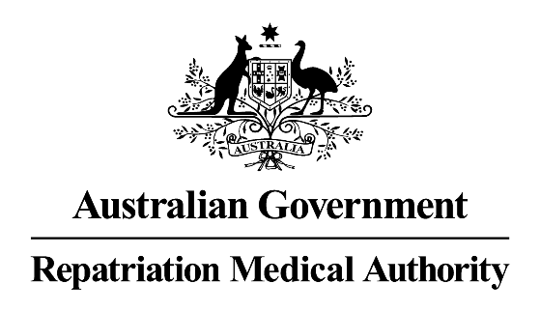

Request for an Investigation/Review
__________________________________________________________________

It is recommended that you read the Repatriation Medical Authority’s Information sheet for Applicants requesting an Investigation/Review.

This form is to be completed by a person or organisation requesting the Repatriation Medical Authority (the Authority) to:

[Please indicate - X]

carry out an investigation in respect of a particular kind of injury, disease or death with a view to make a Statement of Principles; or

t review a decision not to make a Statement of Principles; or

review some or all of the contents of a current Statement of Principles.

Name of person  making request | Mr/Ms/Mrs/Dr

Name of organisation
making request

Email Address | ____________________________________________________

Address for  correspondence | ____________________________________________________  ____________________________________________________
Telephone  Contact | Business Hours After Hours

I make this request as:

[Please indicate - X]

a person eligible to make a claim for compensation under section 319 of the Military Rehabilitation and Compensation Act 2004 (the MRCA);

on behalf of an organisation representing veterans, Australian mariners or members of the Forces;

an organisation representing members or their dependants; or

the Repatriation Commission.

I authorise the release of any information to the Authority:required to establish my eligibility to make this request.

I request that the Authority:

- carry out an investigation into a particular kind of injury, disease or death with a view to make a Statement of Principles concerning ……………………………………………………………………………………………..…………………………………………………………………………………………………………..…
or
- review some or all of the contents of a Statement of Principles concerning …..…………………………………………………………………………………………………………………………………..……………………………………………………………………
or
- review the decision of the Authority NOT to make a Statement of Principles concerning …………………………………………………………………………………………………………………………………………………………..……..………………………………………
Date of Authority decision. ……/………/……

Statement of Principles No/s. ………………………………….

[NB. A separate form must be completed for each condition sought to be reviewed]

In the space provided below, please supply any information which you consider is related to your request. Additional pages may be attached if the space below is insufficient. Should you be requesting the Authority to review the contents of a Statement of Principles, please identify which causal factor(s) you wish to have reviewed or considered for inclusion. You should specify any peer-reviewed published information which supports your request.

………………………………………………………………………………………………………

...................................................................................................................………………...

..........................................................................................................................……..........

..........................................................................................................……...…………….....

.......................................................................………………..…………………………… …

………………………………………...……………………………………………………..…....

…………………………………………...………………………………………….………….....

……………………………………………..…………………………………….…………….....

………………………………………………..………………………………………………......

Disclosure of Information

Under section 370CM of the MRCA, certain decisions made by the Authority are reviewable by the Specialist Medical Review Council (SMRC). If a valid application for review by the SMRC is made, the MRCA requires the Authority to disclose to the SMRC all information relevant to its determination or decision. This includes applications for investigation or review, and submissions received relevant to the matter being review by the SMRC.

Signature of applicant  Organisational position (if relevant)  Date | ......................................................................................…….......  ...................………………………………………………...…….…..  ……/……../………

This form is to be emailed to: info@rma.gov.au

or mailed to: The Registrar
Repatriation Medical Authority
GPO Box 1014
Brisbane Qld 4001

