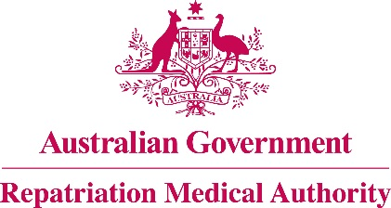

NOTICE OF INVESTIGATION

Section 196G of the

Veterans' Entitlements Act 1986
The Repatriation Medical Authority (the Authority) gives notice under section 196G of the Veterans' Entitlements Act 1986 (the VEA) that it intends to carry out investigations pursuant to subsection 196B(4) of the VEA to find out whether Statements of Principles may be determined in respect of the following:
- bruxism;
- ganglion;
- incisional hernia;
- Scheuermann's disease; and
- umbilical hernia.
The Authority invites the following persons and organisations to make written submissions to the Authority in respect of these investigations:
a person eligible to make a claim for pension under Part II or Part IV of the Veterans' Entitlements Act 1986;
a person eligible to make a claim for compensation under section 319 of the Military Rehabilitation and Compensation Act 2004 (the MRCA);
an organisation representing veterans, Australian mariners, members of the Forces, members of the Peacekeeping Forces, members within the meaning of the MRCA, or their dependants;
the Repatriation Commission or the Military Rehabilitation and Compensation Commission; and
a person having expertise in a field relevant to the investigation.
The Authority will hold its first meeting for the purposes of these investigations on 7 June 2016.
Under the VEA, the Authority is required to find out whether there is information available about how the above listed conditions may be suffered or contracted, or death from the above listed conditions may occur, and the extent to which the above listed conditions or death from the above listed conditions may be war-caused, defence-caused, a service injury, a service disease or a service death. Persons and organisations wishing to make a submission should obtain a copy of the RMA Submission Guidelines from the RMA website [www.rma.gov.au] or by contacting the RMA Secretariat at the address or telephone number below.
All submissions must be in writing and received by the Authority at the address below no later than 20 May 2016.

The Common Seal of the )
Repatriation Medical Authority )
was affixed at the direction of: )
PROFESSOR NICHOLAS SAUNDERS AO
CHAIRPERSON 4/ 12 /2015

