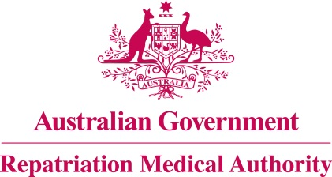

Amendment Statement of Principles

concerning

CERVICAL INTERVERTEBRAL DISC PROLAPSE
(Reasonable Hypothesis)

(No. 29 of 2024)
The Repatriation Medical Authority determines the following Amendment Statement of Principles under subsections 196B(2) and (8) of the Veterans' Entitlements Act 1986.

Dated 22 February 2024

The Common Seal of the
Repatriation Medical Authority
was affixed to this instrument
at the direction of:

Professor Terence Campbell AM
Chairperson

Contents
1 Name 3
2 Commencement 3
3 Authority 3
4 Amendment 3

- Name
This is the Amendment Statement of Principles concerning cervical intervertebral disc prolapse (Reasonable Hypothesis) (No. 29 of 2024).
- Commencement
This instrument commences on 26 March 2024.
- Authority
This instrument is made under subsections 196B(2) and (8) of the Veterans' Entitlements Act 1986.
- Amendment
The Statement of Principles concerning cervical intervertebral disc prolapse (Reasonable Hypothesis) (No. 66 of 2023) (Federal Register of Legislation No. F2023L00915) is amended in the following manner:

Section | Amendment
7(5) | Replace the existing subsection 7(5) with the following:  Whilst cervical intervertebral disc prolapse attracts ICD-10-AM codes M50.0, M50.1 or M50.2, in this Statement of Principles, the definition of "cervical intervertebral disc prolapse" is that given at subsection (3).

