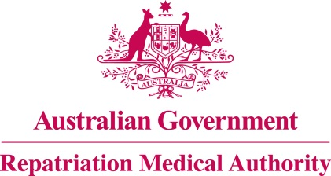

Amendment Statement of Principles

concerning

CUT, STAB, ABRASION AND LACERATION
(Reasonable Hypothesis)

(No. 15 of 2024)
The Repatriation Medical Authority determines the following Amendment Statement of Principles under subsections 196B(2) and (8) of the Veterans' Entitlements Act 1986.

Dated 22 December 2023.

The Common Seal of the
Repatriation Medical Authority
was affixed to this instrument
at the direction of:

Professor Terence Campbell AM
Chairperson

Contents
1 Name 3
2 Commencement 3
3 Authority 3
4 Amendment 3

- Name
This is the Amendment Statement of Principles concerning cut, stab, abrasion and laceration (Reasonable Hypothesis) (No. 15 of 2024).
- Commencement
This instrument commences on 22 January 2024.
- Authority
This instrument is made under subsections 196B(2) and (8) of the Veterans' Entitlements Act 1986.
- Amendment
The Statement of Principles concerning cut, stab, abrasion and laceration (Reasonable Hypothesis) (No. 53 of 2016) (Federal Register of Legislation No. F2016L00567) is amended in the following manner:

Section | Amendment
7(2) | Replace the existing subsection 7(2) with the following:  For the purposes of this statement of principles, cut, stab, abrasion and laceration means:  (a) an injury that interrupts the continuity of the epidermis or other external tissue and causes a wound. The wound may or may not penetrate to the subcutaneous tissues and underlying structures; and  (b) includes friction burns; and  (c) excludes wounds that were caused by:  (i) gunshot;  (ii) missile;  (iii) explosive device or fragment thereof; or  (iv) burns other than friction burns.

