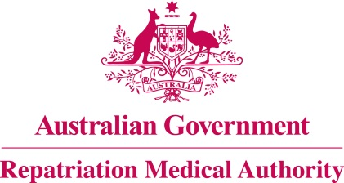

Amendment Statement of Principles

concerning

GINGIVITIS
(Balance of Probabilities)

(No. 116 of 2022)
The Repatriation Medical Authority determines the following Amendment Statement of Principles under subsections 196B(3) and (8) of the Veterans' Entitlements Act 1986.

Dated 21 October 2022

The Common Seal of the
Repatriation Medical Authority
was affixed to this instrument
at the direction of:

Professor Terence Campbell AM
Chairperson

Contents
1 Name 3
2 Commencement 3
3 Authority 3
4 Amendment 3

- Name
This is the Amendment Statement of Principles concerning gingivitis (Balance of Probabilities) (No. 116 of 2022).
- Commencement
This instrument commences on 21 November 2022.
- Authority
This instrument is made under subsections 196B(3) and (8) of the Veterans' Entitlements Act 1986.
- Amendment
The Statement of Principles concerning gingivitis (Balance of Probabilities) (No. 18 of 2022) (Federal Register of Legislation No. F2022L00011) is amended in the following manner:

Section | Amendment
Schedule 1 – Dictionary | Replace the existing definition of "combined oral contraceptive pill as specified " with the following:  combined oral contraceptive pill as specified means an oral contraceptive pill containing estrogen at a minimum dose of 50 micrograms and a progestogen.

