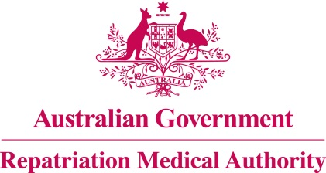

Amendment Statement of Principles

concerning

IMMUNE THROMBOCYTOPAENIA
(Reasonable Hypothesis)

(No. 57 of 2022)
The Repatriation Medical Authority determines the following Amendment Statement of Principles under subsections 196B(2) and (8) of the Veterans' Entitlements Act 1986.

Dated 29 April 2022

The Common Seal of the
Repatriation Medical Authority
was affixed to this instrument
at the direction of:

Professor Terence Campbell AM
Chairperson

Contents
1 Name 3
2 Commencement 3
3 Authority 3
4 Amendment 3

- Name
This is the Amendment Statement of Principles concerning immune thrombocytopaenia (Reasonable Hypothesis) (No. 57 of 2022).
- Commencement
This instrument commences on 30 May 2022.
- Authority
This instrument is made under subsections 196B(2) and (8) of the Veterans' Entitlements Act 1986.
- Amendment
The Statement of Principles concerning immune thrombocytopaenia (Reasonable Hypothesis) (No. 63 of 2017) (Federal Register of Legislation No. F2017L01448) is amended in the following manner:

Section | Amendment
Schedule 1 – Dictionary | Before paragraph (a) of the "specified list of vaccines" insert:  (aa) coronavirus disease 2019 (COVID-19) vaccine;
Schedule 1 – Dictionary | After paragraph (o) of the "specified list of viral infections" insert:  (oa) severe acute respiratory syndrome coronavirus 2 (SARS-CoV-2);
Schedule 1 – Dictionary | Insert the following note to the definition of "specified list of viral infections":  Note: SARS-CoV-2 is the virus which causes coronavirus disease 2019 (COVID-19).

