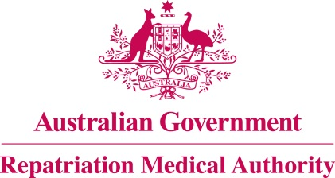

Amendment Statement of Principles

concerning

SENSORINEURAL HEARING LOSS
(Reasonable Hypothesis)

(No. 55 of 2022)
The Repatriation Medical Authority determines the following Amendment Statement of Principles under subsections 196B(2) and (8) of the Veterans' Entitlements Act 1986.

Dated 29 April 2022

The Common Seal of the
Repatriation Medical Authority
was affixed to this instrument
at the direction of:

Professor Terence Campbell AM
Chairperson

Contents
1 Name 3
2 Commencement 3
3 Authority 3
4 Amendment 3

- Name
This is the Amendment Statement of Principles concerning sensorineural hearing loss (Reasonable Hypothesis) (No. 55 of 2022).
- Commencement
This instrument commences on 30 May 2022.
- Authority
This instrument is made under subsections 196B(2) and (8) of the Veterans' Entitlements Act 1986.
- Amendment
The Statement of Principles concerning sensorineural hearing loss (Reasonable Hypothesis) (No. 98 of 2019) (Federal Register of Legislation No. F2019L01360) is amended in the following manner:

Section | Amendment
Schedule 1 – Dictionary | Replace paragraph (n) in the definition of "specified list of chemical agents" with the following paragraph:  (n) xylene;

