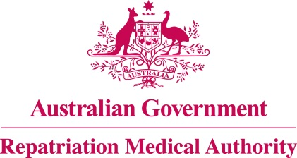

Amendment Statement of Principles

concerning

SUICIDE AND ATTEMPTED SUICIDE
(Balance of Probabilities)

(No. 36 of 2022)
The Repatriation Medical Authority determines the following Amendment Statement of Principles under subsections 196B(3) and (8) of the Veterans' Entitlements Act 1986.

Dated 4 March 2022

The Common Seal of the
Repatriation Medical Authority
was affixed to this instrument
at the direction of:

Professor Terence Campbell AM
Chairperson

Contents
1 Name 3
2 Commencement 3
3 Authority 3
4 Amendment 3

- Name
This is the Amendment Statement of Principles concerning suicide and attempted suicide (Balance of Probabilities) (No. 36 of 2022).
- Commencement
This instrument commences on 4 April 2022.
- Authority
This instrument is made under subsections 196B(3) and (8) of the Veterans' Entitlements Act 1986.
- Amendment
The Statement of Principles concerning suicide and attempted suicide (Balance of Probabilities) (No. 66 of 2016) (Federal Register of Legislation No. F2016L01149) is amended in the following manner:

Section | Amendment
Schedule 1 – Dictionary | After paragraph (k) in the definition of 'clinically significant disorder of mental health as specified', insert the following paragraph:  (ka) gender dysphoria;

