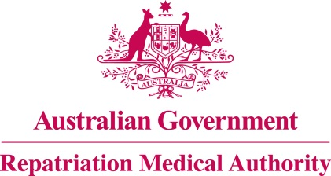

Amendment Statement of Principles

concerning

ASTHMA
(Balance of Probabilities)

(No. 93 of 2022)
The Repatriation Medical Authority determines the following Amendment Statement of Principles under subsections 196B(3) and (8) of the Veterans' Entitlements Act 1986.

Dated 23 August 2022.

The Common Seal of the
Repatriation Medical Authority
was affixed to this instrument
at the direction of:

Professor Terence Campbell AM
Chairperson

Contents
1 Name 3
2 Commencement 3
3 Authority 3
4 Amendment 3

- Name
This is the Amendment Statement of Principles concerning asthma (Balance of Probabilities) (No. 93 of 2022).
- Commencement
This instrument commences on 19 September 2022.
- Authority
This instrument is made under subsections 196B(3) and (8) of the Veterans' Entitlements Act 1986.
- Amendment
The Statement of Principles concerning asthma (Balance of Probabilities) (No. 32 of 2021) (Federal Register of Legislation No. F2021L00220) is amended in the following manner:

Section | Amendment
9(1A) | Insert the following factor as subsection 9(1A):  having a sensitising exposure to an allergen before the clinical onset of asthma;  Note: sensitising exposure to an allergen is defined in the Schedule 1 – Dictionary.
Schedule 1 – Dictionary | Insert the following definition of "sensitising exposure to an allergen" in alphabetical order:  sensitising exposure to an allergen means an exposure to an allergen without the occurrence of symptoms where the clinical onset of asthma occurs within the 24 hours of a subsequent exposure to the same allergen.  Note: The initial sensitising exposure to an allergen may have occurred months to years before the re-exposure that has resulted in the asthma.

