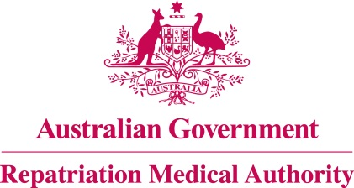

Amendment Statement of Principles

concerning

GUILLAIN-BARRE SYNDROME
(Reasonable Hypothesis)

(No. 74 of 2022)
The Repatriation Medical Authority determines the following Amendment Statement of Principles under subsections 196B(2) and (8) of the Veterans' Entitlements Act 1986.

Dated 24 June 2022

The Common Seal of the
Repatriation Medical Authority
was affixed to this instrument
at the direction of:

Professor Terence Campbell AM
Chairperson

Contents
1 Name 3
2 Commencement 3
3 Authority 3
4 Amendment 3

- Name
This is the Amendment Statement of Principles concerning Guillain-Barre syndrome (Reasonable Hypothesis) (No. 74 of 2022).
- Commencement
This instrument commences on 25 July 2022.
- Authority
This instrument is made under subsections 196B(2) and (8) of the Veterans' Entitlements Act 1986.
- Amendment
The Statement of Principles concerning Guillain-Barre syndrome (Reasonable Hypothesis) (No. 23 of 2018) (Federal Register of Legislation No. F2018L00187) is amended in the following manner:

Section | Amendment
9(5) | Replace the existing factor in subsection 9(5) with the following:  receiving a vaccine from the specified list of vaccines within the two months before the clinical onset of Guillain-Barre syndrome;  Note: specified list of vaccines is defined in the Schedule 1 – Dictionary.
Schedule 1 – Dictionary | Insert the following definition of "specified list of vaccines" in alphabetical order:  specified list of vaccines means:  - coronavirus disease 2019 (COVID-19) vaccine;  - influenza vaccine; or  - nerve tissue derived rabies vaccine.

