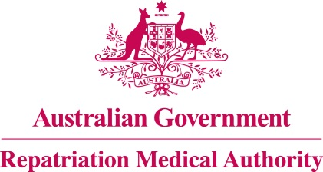

Amendment Statement of Principles

concerning

HYPOPITUITARISM
(Balance of Probabilities)

(No. 82 of 2021)
The Repatriation Medical Authority determines the following Amendment Statement of Principles under subsections 196B(3) and (8) of the Veterans' Entitlements Act 1986.

Dated 25 June 2021

The Common Seal of the
Repatriation Medical Authority
was affixed to this instrument
at the direction of:

Professor Nicholas Saunders AO
Chairperson

Contents
1 Name 3
2 Commencement 3
3 Authority 3
4 Amendment 3

- Name
This is the Amendment Statement of Principles concerning hypopituitarism (Balance of Probabilities) (No. 82 of 2021).
- Commencement
This instrument commences on 26 July 2021.
- Authority
This instrument is made under subsections 196B(3) and (8) of the Veterans' Entitlements Act 1986.
- Amendment
The Statement of Principles concerning hypopituitarism (Balance of Probabilities) (No. 12 of 2019) (Federal Register of Legislation No. F2019L00012) is amended in the following manner:

Section | Amendment
7(2)(a) | Replace the existing definition in paragraph 7(2)(a) with the following:  means an endocrine disease characterised by biochemically-documented deficient production of one or more pituitary hormones, sufficient to produce clinical symptoms and signs, or to necessitate pituitary hormone replacement therapy, as a result of loss or damage to pituitary hormone-secreting cells in the pituitary gland, hypothalamus or pituitary stalk; and

