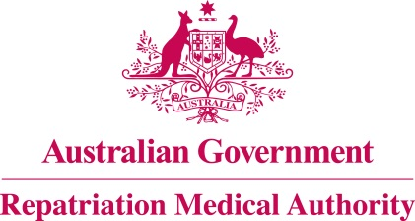

Amendment Statement of Principles

concerning

PILONIDAL SINUS
(Reasonable Hypothesis)

(No. 115 of 2021)
The Repatriation Medical Authority determines the following Amendment Statement of Principles under subsections 196B(2) and (8) of the Veterans' Entitlements Act 1986.

Dated 26 November 2021

The Common Seal of the
Repatriation Medical Authority
was affixed to this instrument
at the direction of:

Professor Terence Campbell AM
Chairperson

Contents
1 Name 3
2 Commencement 3
3 Authority 3
4 Amendment 3

- Name
This is the Amendment Statement of Principles concerning pilonidal sinus (Reasonable Hypothesis) (No. 115 of 2021).
- Commencement
This instrument commences on 20 December 2021.
- Authority
This instrument is made under subsections 196B(2) and (8) of the Veterans' Entitlements Act 1986.
- Amendment
The Statement of Principles concerning pilonidal sinus (Reasonable Hypothesis) (No. 27 of 2019) (Federal Register of Legislation No. F2019L00248) is amended in the following manner:

Section | Amendment
9(2)(aa) | Insert the following new factor into paragraph 9(2)(aa):  sitting on a hard or vibrating surface for an average of at least 20 hours per week for a period of at least three months, within the six months before the clinical onset of pilonidal sinus; or
9(5)(aa) | Insert the following new factor into paragraph 9(5)(aa):  sitting on a hard or vibrating surface for an average of at least 20 hours per week for a period of at least three months, within the six months before the clinical worsening of pilonidal sinus; or

