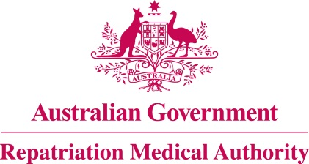

Amendment Statement of Principles

concerning

ISCHAEMIC HEART DISEASE
(Reasonable Hypothesis)

(No. 55 of 2021)
The Repatriation Medical Authority determines the following Amendment Statement of Principles under subsections 196B(2) and (8) of the Veterans' Entitlements Act 1986.

Dated 23 April 2021

The Common Seal of the
Repatriation Medical Authority
was affixed to this instrument
at the direction of:

Professor Nicholas Saunders AO
Chairperson

Contents
1 Name 3
2 Commencement 3
3 Authority 3
4 Amendment 3

- Name
This is the Amendment Statement of Principles concerning ischaemic heart disease (Reasonable Hypothesis) (No. 55 of 2021).
- Commencement
This instrument commences on 24 May 2021.
- Authority
This instrument is made under subsections 196B(2) and (8) of the Veterans' Entitlements Act 1986.
- Amendment
The Statement of Principles concerning ischaemic heart disease (Reasonable Hypothesis) (No. 1 of 2016) (Federal Register of Legislation No. F2016L00001) is amended in the following manner:
Section | Amendment
9(43) | Insert the following paragraph after paragraph 9(43)(k):  (ka) having infection with severe acute respiratory syndrome coronavirus 2 (SARS-CoV-2) within the 30 days before the clinical onset of ischaemic heart disease;
9(43) | In the existing note to subsection 9(43), insert the numeral "2" after the word "Note".
9(43) | Insert the following note before the amended "Note 2":  Note 1: SARS-CoV-2 is the virus which causes coronavirus disease 2019 (COVID-19).
9(86) | Insert the following paragraph after paragraph 9(86)(k):  (ka) having infection with severe acute respiratory syndrome coronavirus 2 (SARS-CoV-2) within the 30 days before the clinical worsening of ischaemic heart disease;
9(86) | In the existing note to subsection 9(86), insert the numeral "2" after the word "Note".
9(86) | Insert the following note before the amended "Note 2":  Note 1: SARS-CoV-2 is the virus which causes coronavirus disease 2019 (COVID-19).

