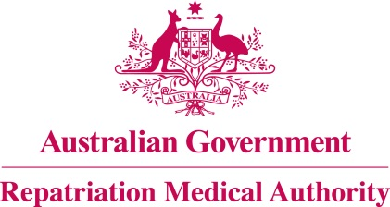

Amendment Statement of Principles

concerning

NON-HODGKIN LYMPHOMA
(Reasonable Hypothesis)

(No. 75 of 2021)
The Repatriation Medical Authority determines the following Amendment Statement of Principles under subsections 196B(2) and (8) of the Veterans' Entitlements Act 1986.

Dated 21 May 2021

The Common Seal of the
Repatriation Medical Authority
was affixed to this instrument
at the direction of:

Professor Nicholas Saunders AO
Chairperson

Contents
1 Name 3
2 Commencement 3
3 Authority 3
4 Amendment 3

- Name
This is the Amendment Statement of Principles concerning non-Hodgkin lymphoma (Reasonable Hypothesis) (No. 75 of 2021).
- Commencement
This instrument commences on 21 June 2021.
- Authority
This instrument is made under subsections 196B(2) and (8) of the Veterans' Entitlements Act 1986.
- Amendment
The Statement of Principles concerning non-Hodgkin lymphoma (Reasonable Hypothesis) (No. 90 of 2018) (Federal Register of Legislation No. F2018L01489) is amended in the following manner:

Section | Amendment
9(8) | Delete the words "at the time of" in subsection 9(8) and substitute them with the word "before".

