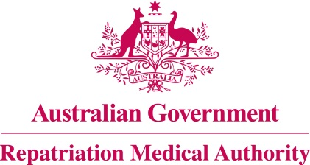

Amendment Statement of Principles

concerning

GUILLAIN-BARRE SYNDROME
(Balance of Probabilities)

(No. 58 of 2021)
The Repatriation Medical Authority determines the following Amendment Statement of Principles under subsections 196B(3) and (8) of the Veterans' Entitlements Act 1986.

Dated 23 April 2021

The Common Seal of the
Repatriation Medical Authority
was affixed to this instrument
at the direction of:

Professor Nicholas Saunders AO
Chairperson

Contents
1 Name 3
2 Commencement 3
3 Authority 3
4 Amendment 3

- Name
This is the Amendment Statement of Principles concerning Guillain-Barre syndrome (Balance of Probabilities) (No. 58 of 2021).
- Commencement
This instrument commences on 24 May 2021.
- Authority
This instrument is made under subsections 196B(3) and (8) of the Veterans' Entitlements Act 1986.
- Amendment
The Statement of Principles concerning Guillain-Barre syndrome (Balance of Probabilities) (No. 24 of 2018) (Federal Register of Legislation No. F2018L00189) is amended in the following manner:

Section | Amendment
9(1) | Delete the words "with an organism".
Schedule 1 – Dictionary | After paragraph (k) in the definition of "specified list of infections", insert the following paragraph:  (ka) severe acute respiratory syndrome coronavirus 2 (SARS-CoV-2);
Schedule 1 – Dictionary | Insert the following note to the definition of "specified list of infections":  Note: SARS-CoV-2 is the virus which causes coronavirus disease 2019 (COVID-19).

