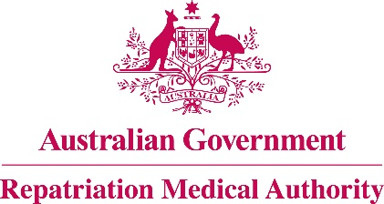

Amendment Statement of Principles

concerning

**CERVICAL SPONDYLOSIS**

**No. 102 of 2019**

for the purposes of the

*Veterans' Entitlements Act 1986*

and

*Military Rehabilitation and Compensation Act 2004*

1. This Instrument may be cited as Amendment Statement of Principles concerning cervical spondylosis No. 102 of 2019.
2. The Repatriation Medical Authority amends, under subsection 196B(8) of the *Veterans' Entitlements Act 1986*,Statement of Principles concerning cervical spondylosis Instrument No. 66 of 2014 (Federal Register of Legislation No. F2014L00928) by:
3. Amending paragraph 6 by inserting new factors (ia) & (va) as follows:

"(ia) carrying a large bulky load of at least 15 kilograms positioned between the neck and shoulder to a cumulative total of at least 5 000 hours within any ten year period before the clinical onset of cervical spondylosis; or"; and

"(va) carrying a large bulky load of at least 15 kilograms positioned between the neck and shoulder to a cumulative total of at least 5 000 hours within any ten year period before the clinical worsening of cervical spondylosis; or".

1. The amendments made by this instrument commence on 18 November 2019.

Dated 18 October 2019

|  |  |
| --- | --- |
| The Common Seal of the )  Repatriation Medical Authority )  was affixed to this instrument )  at the direction of: ) |  |
|  | PROFESSOR NICHOLAS SAUNDERS AO CHAIRPERSON |