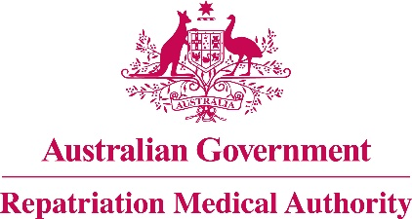

Amendment Statement of Principles

concerning

**MOTOR NEURONE DISEASE**

**No. 99 of 2018**

for the purposes of the

*Veterans’ Entitlements Act 1986*

and

*Military Rehabilitation and Compensation Act 2004*

1. This Instrument may be cited as Amendment Statement of Principles concerning motor neurone disease No. 99 of 2018.
2. In accordance with the Specialist Medical Review Council Declaration No. 31 of 20 June 2018 under subsection 196W(4) of the *Veterans' Entitlements Act 1986* (the VEA), the Repatriation Medical Authority, pursuant to subsection 196B(10) of the VEA, makes this determination amending Statement of Principles concerning motor neurone disease Instrument No. 67 of 2013 (Federal Register of Legislation No. F2018C00590), by :

* Replacing the existing paragraph 7 with the following:

"**7.** Paragraph **6(b)** applies only to material contribution to, or aggravation of, motor neurone disease where the person’s motor neurone disease was suffered or contracted before or during (but not arising out of) the person’s relevant service.".

1. The amendment made by this instrument commences on 21 June 2018.

Dated 26 October 2018

|  |  |
| --- | --- |
| The Common Seal of the )  Repatriation Medical Authority )  was affixed to this instrument )  at the direction of: ) |  |
|  | PROFESSOR NICHOLAS SAUNDERS AO CHAIRPERSON |