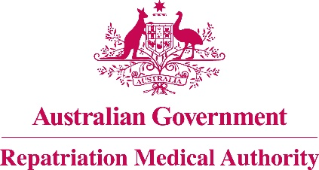

Amendment Statement of Principles

concerning

**MALIGNANT NEOPLASM OF THE PROSTATE**

**No. 19 of 2017**

for the purposes of the

*Veterans’ Entitlements Act 1986*

and

*Military Rehabilitation and Compensation Act 2004*

1. This Instrument may be cited as Amendment Statement of Principles concerning malignant neoplasm of the prostate No. 19 of 2017.
2. Pursuant to subsection 196B(8) of the *Veterans’ Entitlements Act 1986* (the VEA), the Repatriation Medical Authority amends Statement of Principles concerning malignant neoplasm of the prostate Instrument No. 53 of 2014, by:
   1. Repealing factor "(e)" in clause 6 and substituting the following:

"(e) smoking at least ten pack-years of cigarettes, or the equivalent thereof in other tobacco products, before the clinical worsening of malignant neoplasm of the prostate, and where smoking has ceased, the clinical worsening of malignant neoplasm of the prostate has occurred within ten years of cessation; or".

1. The amendment made by this instrument applies to all matters to which Instrument No. 53 of 2014, section 120A of the *Veterans’ Entitlements Act 1986* and section 338 of the *Military Rehabilitation and Compensation Act 2004* apply.
2. The amendment made by this instrument commences on 23 January 2017.

Dated this twentieth day of December 2016

The Common Seal of the )

Repatriation Medical Authority )

was affixed to this instrument )

at the direction of: )

PROFESSOR NICHOLAS SAUNDERS AO

CHAIRPERSON