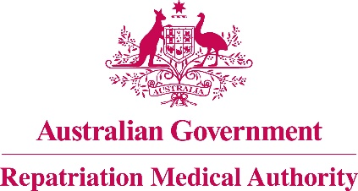

Amendment Statement of Principles

concerning

**OTITIC BAROTRAUMA**

**No. 15 of 2017**

for the purposes of the

*Veterans’ Entitlements Act 1986*

and

*Military Rehabilitation and Compensation Act 2004*

1. This Instrument may be cited as Amendment Statement of Principles concerning otitic barotrauma No. 15 of 2017.
2. The Repatriation Medical Authority amends, under subsection 196B(8) of the *Veterans’ Entitlements Act 1986*,Statement of Principles concerning otitic barotrauma Instrument No. 35 of 2012, by:
3. Replacing the definition of "a change in the ambient barometric pressure as specified" in clause 9 with the following:

'**"a change in the ambient barometric pressure as specified"** means a significant and rapid reduction or increase in the pressure surrounding the person, including in such circumstances as:

1. ascending from a submerged craft or device or a submarine escape training facility;
2. decompression or compression in a hypobaric or hyperbaric chamber;
3. flying;
4. sky diving;
5. underwater diving;
6. working in a submarine; or
7. working in a pressurised chamber or tunnel;'.
8. The amendment made by this instrument applies to all matters to which Instrument No. 35 of 2012, section 120A of the *Veterans’ Entitlements Act 1986* and section 338 of the *Military Rehabilitation and Compensation Act 2004* apply.
9. The amendment made by this instrument commences on 23 January 2017.

Dated this twentieth day of December 2016

The Common Seal of the )

Repatriation Medical Authority )

was affixed to this instrument )

at the direction of: )

PROFESSOR NICHOLAS SAUNDERS AO

CHAIRPERSON