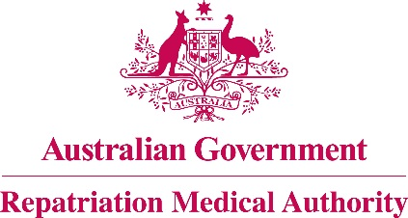

Amendment Statement of Principles

concerning

**APLASTIC ANAEMIA**

**No. 31 of 2016**

for the purposes of the

*Veterans’ Entitlements Act 1986*

and

*Military Rehabilitation and Compensation Act 2004*

1. This Instrument may be cited as Amendment Statement of Principles concerning aplastic anaemia No. 31 of 2016.
2. The Repatriation Medical Authority amends, under subsection 196B(8) of the *Veterans’ Entitlements Act 1986*,Statement of Principles concerning aplastic anaemia Instrument No. 50 of 2012, by:
3. Replacing existing factor "(g)" in clause 6 as follows:

"(g) being exposed to benzene as specified on at least 30 days within the six months before the clinical onset of aplastic anaemia; or"; and

1. Replacing the definition of "being exposed to benzene" in clause 9 with the definition of "being exposed to benzene as specified" as follows:

'**"being exposed to benzene as specified"**means:

1. having cutaneous contact with liquids containing benzene greater than 5% by volume; or
2. ingesting liquids containing benzene greater than 5% by volume; or
3. inhaling benzene vapour where such exposure occurs at an ambient 8-hour time-weighted average benzene concentration exceeding five parts per million;'.
4. The amendments made by this instrument apply to all matters to which Instrument No. 50 of 2012, section 120A of the *Veterans’ Entitlements Act 1986* and section 338 of the *Military Rehabilitation and Compensation Act 2004* apply.
5. The amendments made by this instrument take effect from 4 April 2016.

Dated this fourth day of March 2016

The Common Seal of the )

Repatriation Medical Authority )

was affixed at the direction of: )

PROFESSOR NICHOLAS SAUNDERS AO

CHAIRPERSON