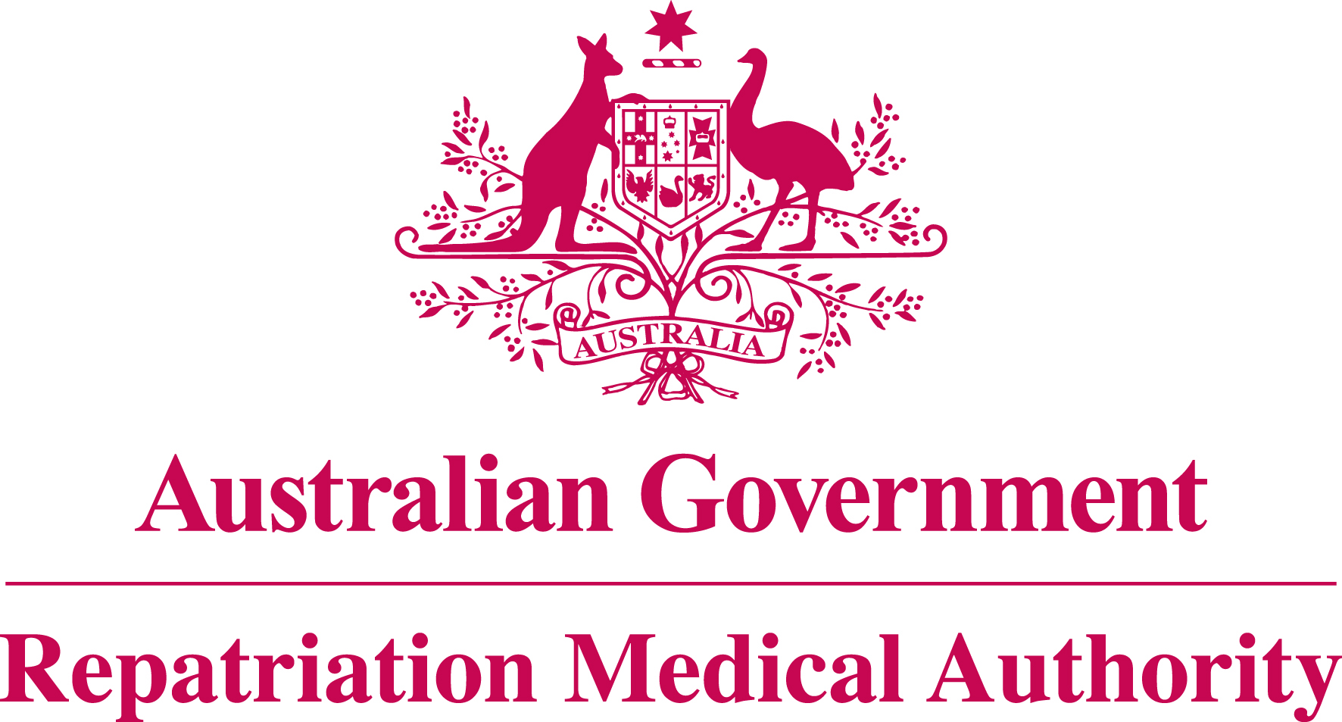

Statement of Principles

concerning

MODERATE TO SEVERE TRAUMATIC BRAIN INJURY

No. 63 of 2012

for the purposes of the

Veterans’ Entitlements Act 1986
and

Military Rehabilitation and Compensation Act 2004

Title
1. This Instrument may be cited as Statement of Principles concerning moderate to severe traumatic brain injury No. 63 of 2012.

Determination
2. This Statement of Principles is determined by the Repatriation Medical Authority under subsection 196B(3) of the Veterans’ Entitlements Act 1986 (the VEA).

Kind of injury, disease or death
3. (a) This Statement of Principles is about moderate to severe traumatic brain injury and death from moderate to severe traumatic brain injury.
(b) For the purposes of this Statement of Principles, "moderate to severe traumatic brain injury" means significant damage to the brain resulting from the transfer of kinetic energy to the brain from external physical forces, as manifested by at least one of the following clinical signs:
  - loss of consciousness for 30 minutes or more;
  - anterograde amnesia for 24 hours or more;
  - an intracranial lesion;
  - penetration of the dura mater; or
  - a Glasgow Coma Scale score of less than 13.
This definition excludes injury from radiation, electricity, heat or surgery.
Note: This Statement of Principles applies to the direct effects of traumatic brain injury. Trauma to the brain can cause other diseases or injuries and these are covered by a range of other Statements of Principles in which trauma to the brain (variously worded) is listed as a risk factor. The relevant Statements of Principles include but are not limited to: epilepsy, epileptic seizure, subdural haematoma, subarachnoid haemorrhage, deep vein thrombosis, cerebrovascular accident, Meniere's disease, anosmia, hypopituitarism, narcolepsy, Parkinson's disease and parkinsonism, Alzheimer-type dementia and dementia pugilistica.

Basis for determining the factors
4. On the sound medical-scientific evidence available, the Repatriation Medical Authority is of the view that it is more probable than not that moderate to severe traumatic brain injury and death from moderate to severe traumatic brain injury can be related to relevant service rendered by veterans or members of the Forces under the VEA, or members under the Military Rehabilitation and Compensation Act 2004 (the MRCA).

Factors that must be related to service
5. Subject to clause 7, at least one of the factors set out in clause 6 must be related to the relevant service rendered by the person.

Factors
6. The factor that must exist before it can be said that, on the balance of probabilities, moderate to severe traumatic brain injury or death from moderate to severe traumatic brain injury is connected with the circumstances of a person’s relevant service is:
- experiencing a significant force from a specified event at the time of the clinical onset of moderate to severe traumatic brain injury; or
- inability to obtain appropriate clinical management for moderate to severe traumatic brain injury.

Factors that apply only to material contribution or aggravation
7. Paragraph 6(b) applies only to material contribution to, or aggravation of, moderate to severe traumatic brain injury where the person’s moderate to severe traumatic brain injury was suffered or contracted before or during (but not arising out of) the person’s relevant service.

Inclusion of Statements of Principles
8. In this Statement of Principles if a relevant factor applies and that factor includes an injury or disease in respect of which there is a Statement of Principles then the factors in that last mentioned Statement of Principles apply in accordance with the terms of that Statement of Principles as in force from time to time.

Other definitions
9. For the purposes of this Statement of Principles:
"a specified event" means:
- the head being struck by an object;
- the head striking an object;
- the brain undergoing an acceleration or deceleration movement without direct external trauma to the head;
- a foreign body penetrating the brain; or
- an explosion or explosive blast;
"death from moderate to severe traumatic brain injury" in relation to a person includes death from a terminal event or condition that was contributed to by the person’s moderate to severe traumatic brain injury;
"relevant service" means:
- eligible war service (other than operational service) under the VEA;
- defence service (other than hazardous service and British nuclear test defence service) under the VEA; or
- peacetime service under the MRCA;
"terminal event" means the proximate or ultimate cause of death and includes:
- pneumonia;
- respiratory failure;
- cardiac arrest;
- circulatory failure; or
- cessation of brain function.

Date of effect
10. This Instrument takes effect from 5 September 2012.
Dated this twenty-seventh day of August 2012

