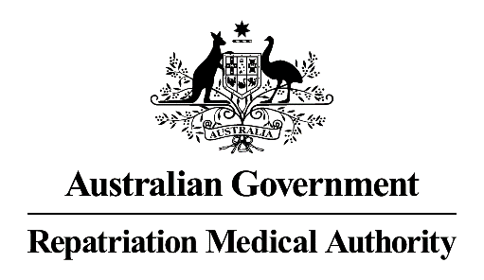

Information for Applicants Requesting an Investigation/Review
______________________________________________________________________

It is recommended that you read this information before completing the Request for an Investigation/Review Form.

The Repatriation Medical Authority

The Repatriation Medical Authority (the Authority) was established in 1994 under the Veterans’ Entitlements Act 1986.
The Authority is comprised of five eminent medical practitioners and medical scientists. It meets regularly to determine Statements of Principles concerning different kinds of injury, disease or death for the purposes of the Veterans’ Entitlements Act 1986 (the VEA) and the Military Rehabilitation and Compensation Act 2004 (the MRCA).
The Authority can investigate a particular kind of injury, disease or death of its own initiative or upon request by persons or organisations identified in the VEA and MRCA.

Who can Lodge a Request?

- A person eligible to make a claim for pension under Part II or IV of the VEA (that is, a veteran or a dependent of a veteran, or a member of the Forces or Peacekeeping Forces or a dependant of a member who is eligible to claim a repatriation pension about the injury, disease or death of the veteran or member); or

- a person eligible to make a claim for compensation under section 319 of the MRCA (that is, a member or a dependent of a deceased member); or

- an organisation representing veterans, Australian mariners, members of the Forces, members of Peacekeeping Forces, members within the meaning of the MRCA, or their dependants; or

- the Repatriation Commission or the Military Rehabilitation and Compensation Commission.

What Can the Authority be Requested to Do Under S.196E of the VEA?

- an investigation in respect of a particular kind of injury, disease or death with a view to making a Statement of Principles; or

- to review a decision not to make a Statement of Principles; or

- to review some or all of the contents of an existing Statement of Principles.

When Can a Request for an Investigation or Review be Lodged?

No time limits are applicable in relation to the above requests.

Can a Request for an Investigation be Declined by the Authority?

Yes. There are a number of situations where the Authority can decide to decline to carry out an investigation in respect of a particular kind of injury, disease or death. These are contained in ss.196C(4) and s.196CA of the VEA, and are as follows:

Ss.196C(4)
- If it is less than 12 months since the Authority:
► determined a Statement of Principles; or
► amended a Statement of Principles; or
► declared that it does not propose to make or amend a Statement of Principles in respect of that particular kind of injury, disease or death; and
► the Authority thinks there are no grounds for such a review.

S.196CA
- If the request does not state the grounds on which the review is sought (ss.196CA(1)(a) of the VEA refers);
or

- the Authority considers that the request does not identify sufficient relevant information to support the grounds on which the review is sought or to otherwise justify the review (ss.196CA(1)(b) of the VEA refers);
or

- the request is vexatious or frivolous (ss.196CA(1)(c) of the VEA refers).

As the Authority must rely upon “sound medical-scientific evidence” as defined in s.5AB of the VEA (refer below) in the determination of Statements of Principles, it is important to bear this definition in mind when providing any information for the Authority to consider.

S.5AB - Information about a particular kind of injury, disease or death is taken to be sound medical-scientific evidence if:

(a) the information:

(i) is consistent with material relating to medical science that has been published in a medical or scientific publication and has been, in the opinion of the Repatriation Medical Authority, subjected to a peer review process; or

- in accordance with generally accepted medical practice, would serve as the basis for the diagnosis and management of a medical condition; and

- in the case of information about how that kind of injury, disease or death may be caused - meets the applicable criteria for assessing causation currently applied in the field of epidemiology.

Other Important Notes for Persons Requesting an Investigation

A request to the Authority must be made on the approved Request for an Investigation/Review Form. A separate Request Form must be completed for each particular request. A request can be completed and submitted on-line, together with any supporting materials or can be mailed or emailed to: info@rma.gov.au.

Repatriation Medical Authority GPO Box 1014
Brisbane Qld 4001

The Authority does not make or review decisions about individual claims for pension, benefits or compensation. If you have any queries regarding such claims, you should contact the Department of Veterans’ Affairs.

Information Privacy Principles (IPP)

In accordance with IPP Principle 2, please be advised that:

- any personal information requested on the Request for an Investigation/Review Form is required in order to process this request for investigation or review; and

- the Authority may disclose personal information to the Repatriation Commission, the Military Rehabilitation and Compensation Commission and/or the Specialist Medical Review Council.

Disclosure of Information

Under section 196K of the VEA, certain decisions made by the Authority are reviewable by the Specialist Medical Review Council (SMRC). If a valid application for review by the SMRC is made, the VEA requires the Authority to disclose to the SMRC all information relevant to its determination or decision. This includes applications for investigation or review, and submissions received relevant to the matter being reviewed by the SMRC.

