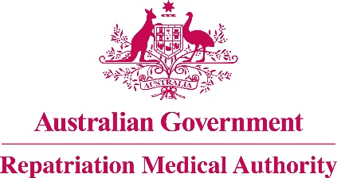

NOTICE OF INVESTIGATION – GINGIVITIS

Section 196G of the

Veterans' Entitlements Act 1986
The Repatriation Medical Authority (the Authority) gives notice under section 196G of the Veterans' Entitlements Act 1986 (the VEA) that, pursuant to subsection 196B(7A) of the VEA, it intends to carry out an investigation in respect of the definition of 'combined oral contraceptive pill as specified' as a factor in gingivitis.
This investigation will be carried out in the context of Statements of Principles Instrument Nos. 17 & 18 of 2022, concerning gingivitis.
The Authority invites the following persons and organisations to make written submissions to the Authority in respect of the investigation:
a person eligible to make a claim for pension under Part II or Part IV of the VEA;
a person eligible to make a claim for compensation under section 319 of the Military Rehabilitation and Compensation Act 2004 (the MRCA);
an organisation representing veterans, Australian mariners, members of the Forces, members of the Peacekeeping Forces, members within the meaning of the MRCA, or their dependants;
the Repatriation Commission or the Military Rehabilitation and Compensation Commission; and
a person having expertise in a field relevant to the investigation.
The Authority will hold its first meeting for the purposes of this investigation on 2 August 2022.
Persons and organisations wishing to make a submission can use the RMA website http://www.rma.gov.au/investigations/ to electronically lodge the submission and supporting information. Alternatively, submissions can be sent by email to info@rma.gov.au or posted to the address below. The RMA Submission Guidelines are available online for guidance. The RMA Secretariat may be contacted at the address, telephone number or email address below for further assistance.
All submissions must be in writing and received by the Authority no later than 20 July 2022.

The Common Seal of the )
Repatriation Medical Authority )
was affixed at the direction of: )
PROFESSOR TERENCE CAMPBELL AM CHAIRPERSON 24 June 2022

