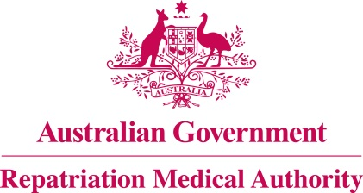

NOTICE OF INVESTIGATION

Section 196G of the

Veterans' Entitlements Act 1986
The Repatriation Medical Authority (the Authority) gives notice under section 196G of the Veterans' Entitlements Act 1986 (the VEA) that it intends to carry out investigations under subsection 196B(7) of the VEA to review the contents of Statements of Principles concerning the following:
Condition: | Instrument Nos.:
allergic rhinitis | 22 and 23 of 2014
narcolepsy | 7 and 8 of 2014, as amended
periodic limb movement disorder | 26 and 27 of 2014
restless legs syndrome | 20 and 21 of 2014
somatic symptom disorder | 24 and 25 of 2014
The Authority invites the following persons and organisations to make written submissions to the Authority in respect of any of the investigations:
a person eligible to make a claim for pension under Part II or Part IV of the VEA;
a person eligible to make a claim for compensation under section 319 of the Military Rehabilitation and Compensation Act 2004 (the MRCA);
an organisation representing veterans, Australian mariners, members of the Forces, members of the Peacekeeping Forces, members within the meaning of the MRCA, or their dependants;
the Repatriation Commission or the Military Rehabilitation and Compensation Commission; and
a person having expertise in a field relevant to the investigation.
The Authority will hold its first meeting for the purposes of each of these investigations on 6 October 2021.
Under the VEA, the Authority is required to find out whether there is new information available about how the above listed conditions may be suffered or contracted, or death from the above listed conditions may occur; and the extent to which the above listed conditions or death from the above listed conditions may be war-caused, defence-caused, a service injury, a service disease or a service death.
Persons and organisations wishing to make a submission can use the RMA website http://www.rma.gov.au/investigations/ to electronically lodge the submission and supporting information. Alternatively, submissions can be sent by email to info@rma.gov.au or posted to the address below. The RMA Submission Guidelines are available online for guidance. The RMA Secretariat may be contacted at the address, telephone number or email address below for further assistance.
All submissions must be in writing and received by the Authority no later than 17 September 2021.
The Common Seal of the )
Repatriation Medical Authority )
was affixed at the direction of: )
PROFESSOR NICHOLAS SAUNDERS AO CHAIRPERSON 23 / 04 / 2021

