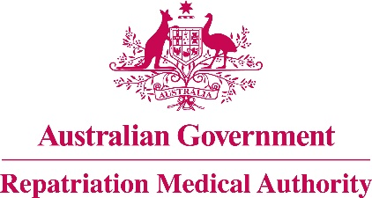

**NOTICE OF INVESTIGATION**

**Section 196G of the**

*Veterans' Entitlements Act 1986*

The Repatriation Medical Authority (the Authority) gives notice under section 196G of the *Veterans' Entitlements Act 1986* (the VEA) that it intends to carry out an investigation under subsection 196B(7) of the VEA to review the contents of Statements of Principles Instrument Nos. 59 & 60 of 2013 concerning **Guillain-Barre syndrome**.

The Authority invites the following persons and organisations to make written submissions to the Authority in respect of the investigation:

a person eligible to make a claim for pension under Part II or Part IV of the *Veterans' Entitlements Act 1986*;

a person eligible to make a claim for compensation under section 319 of the *Military Rehabilitation and Compensation Act 2004* (the MRCA);

an organisation representing veterans, Australian mariners, members of the Forces, members of the Peacekeeping Forces, members within the meaning of the MRCA, or their dependants;

the Repatriation Commission or the Military Rehabilitation and Compensation Commission; and

a person having expertise in a field relevant to the investigation.

The Authority will hold its first meeting for the purposes of this investigation on **4 April 2017**.

Under the VEA, the Authority is required to find out whether there is new information available about how **Guillain-Barre syndrome** may be suffered or contracted, or death from **Guillain-Barre syndrome** may occur, and the extent to which **Guillain-Barre syndrome** or death from **Guillain-Barre syndrome** may be war-caused, defence-caused, a service injury, a service disease or a service death. Persons and organisations wishing to make a submission can use the RMA website [www.rma.gov.au/investigations/] to electronicallylodge the submission and supporting information. Alternatively, submissions can be sent by email to [info@rma.gov.au](mailto:info@rma.gov.au) or posted to the address below. The *RMA Submission Guidelines* are available online for guidance. TheRMA Secretariat may be contacted at the telephone number or email address below for further assistance.

All submissions must be in writing and received by the Authority no later than **17 March 2017**.

The Common Seal of the )

Repatriation Medical Authority )

was affixed at the direction of: )

PROFESSOR NICHOLAS SAUNDERS AO

CHAIRPERSON 20/12/2016