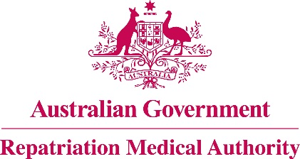

**NOTICE OF INVESTIGATION**

**Section 196G of the**

*Veterans' Entitlements Act 1986*

The Repatriation Medical Authority (the Authority) gives notice under section 196G of the *Veterans' Entitlements Act 1986* (the VEA) that, pursuant to subsection 196B(7A) of the VEA, it intends to carry out an investigation in respect of **smoking** and **passive smoking** as causal factors in **diabetes mellitus**.

This investigation will be carried out in the context of Statements of Principles concerning **diabetes mellitus** Nos. 89 & 90 of 2011, as amended.

This Notice of Investigation broadens the terms of the previously advertised Notice of Investigation which appeared in the Government Notices Gazette of 2 October 2015.

The Authority invites the following persons and organisations to make written submissions to the Authority in respect of the investigation:

a person eligible to make a claim for pension under Part II or Part IV of the *Veterans' Entitlements Act 1986*;

a person eligible to make a claim for compensation under section 319 of the *Military Rehabilitation and Compensation Act 2004* (the MRCA);

an organisation representing veterans, Australian mariners, members of the Forces, members of the Peacekeeping Forces, members within the meaning of the MRCA, or their dependants;

the Repatriation Commission or the Military Rehabilitation and Compensation Commission; and

a person having expertise in a field relevant to the investigation.

The Authority will hold its first meeting for the purposes of this investigation on **9 February 2016**.

Persons and organisations wishing to make a submission should obtain a copy of the *RMA Submission Guidelines* from the RMA website [***www.rma.gov.au***]or by contacting theRMA Secretariat at the address or telephone number below.

All submissions must be in writing and received by the Authority at the address below no later than **22 January 2016**.

The Common Seal of the )

Repatriation Medical Authority )

was affixed at the direction of: )

PROFESSOR NICHOLAS SAUNDERS AO

CHAIRPERSON 4 / 12 /2015