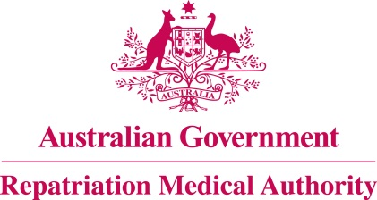

DECLARATION – MALIGNANT NEOPLASM OF THE BRAIN – CARBAMATE INSECTICIDES AND FUNGICIDES

Subsection 196B(9) of the

Veterans' Entitlements Act 1986
The Repatriation Medical Authority (the Authority), under subsection 196B(9) of the Veterans’ Entitlements Act 1986 (the Act), makes the following declaration in respect of the focussed review of the contents of the Statements of Principles in force under the Act concerning malignant neoplasm of the brain, Instrument Nos. 85 and 86 of 2016, as amended.
The investigation related to exposure to carbamate insecticides and fungicides. The Notice of Investigation was published in the Commonwealth of Australia Gazette of 1 June 2021.
Following the investigation, the Authority declares that it does not propose to amend Statements of Principles, Instrument Nos. 85 and 86 of 2016, as amended, to include factors relating to exposure to carbamate insecticides and fungicides. The sound medical-scientific evidence available to the Authority, including the new sound medical-scientific evidence, does not establish that there is at least a reasonable hypothesis that exposure to carbamate insecticides and fungicides is a factor for malignant neoplasm of the brain.
Consequently, the sound medical-scientific evidence is not sufficient to justify an amendment to the Statements of Principles, Nos. 85 and 86 of 2016, as amended, already determined in respect of malignant neoplasm of the brain, to include factors relating to exposure to carbamate insecticides and fungicides.

The Common Seal of the )
Repatriation Medical Authority )
was affixed at the direction of: )
PROFESSOR TERENCE CAMPBELL AM CHAIRPERSON 20 / 08 / 2021

