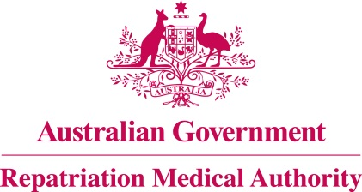

DECLARATION

Subsection 196B(9) of the

Veterans' Entitlements Act 1986
The Repatriation Medical Authority (the Authority), under subsection 196B(9) of the Veterans’ Entitlements Act 1986 (the Act), makes the following declaration in respect of the focussed review of the contents of the Statements of Principles in force under the Act concerning malignant neoplasm of the breast, Instrument Nos. 96 and 97 of 2014, as amended.
The investigation related to taking combined hormonal contraceptives. The Notice of Investigation was published in the Commonwealth of Australia Gazette of 9 March 2021.
Following the investigation, the Authority declares that it does not propose to amend Statements of Principles, Instrument Nos. 96 and 97 of 2014, as amended, to replace the current factors relating to using a combined oral contraceptive pill, with factors relating to taking combined hormonal contraceptives. The sound medical-scientific evidence available to the Authority, including the new sound medical-scientific evidence, does not establish that there is at least a reasonable hypothesis that taking combined hormonal contraceptives (other than a combined oral contraceptive pill) is a factor for malignant neoplasm of the breast.
Consequently, the sound medical-scientific evidence is not sufficient to justify an amendment to the Statements of Principles, Nos. 96 and 97 of 2014, as amended, already determined in respect of malignant neoplasm of the breast, to include factors relating to taking combined hormonal contraceptives.
The Common Seal of the )
Repatriation Medical Authority )
was affixed at the direction of: )
PROFESSOR NICHOLAS SAUNDERS AO CHAIRPERSON 23 / 04 / 2021

