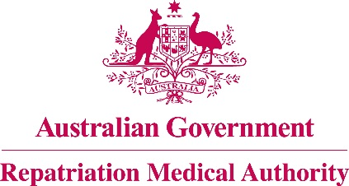

**DECLARATION UNDER SUBSECTION 196B(9)**

**OF THE *VETERANS’ ENTITLEMENTS ACT 1986***

The Repatriation Medical Authority (the Authority), under subsection 196B(9) of the *Veterans' Entitlements Act 1986* (the Act), makes the following declaration in respect of the review of the contents of the Statement of Principles in force under the Act concerning **psoriasis**, Instrument No. 32 of 2012.

The investigation related to "stressors". The Notice of Investigation was published in the Government Notices Gazette of 12 March 2019.

Following the investigation, the Authority declares that it does not propose to amend Statement of Principles, Instrument No. 32 of 2012, by inclusion of a factor relating to exposure to stressors. The reason is that the new sound medical-scientific evidence available is not sufficient to justify an amendment to that Statement of Principles already determined in respect of psoriasis.

The Authority is of the view that the new sound medical-scientific evidence available raises a reasonable hypothesis that psoriasis can be related to service involving exposure to stressors. Factors concerning stressors are included in the existing Statement of Principles concerning psoriasis, Instrument No. 31 of 2012, already determined pursuant to subsection 196B(2) of the Act. However, the sound medical-scientific evidence available to it including the new sound medical-scientific evidence, does not establish that such a relationship is more probable than not and does not enable the Authority to determine factors concerning exposure to stressors for inclusion in the Statement of Principles, Instrument No. 32 of 2012, already determined pursuant to subsection 196B(3) of the Act.

|  |  |
| --- | --- |
| The Common Seal of the )  Repatriation Medical Authority )  was affixed at the direction of: ) |  |
|  | PROFESSOR NICHOLAS SAUNDERS AO CHAIRPERSON 21 / 6 / 2019 |